

Lab Manual
Subject: Programming of AI

By
M. Hamza Rizwan 2023-BS-AI-005
Semester 5th
Course Code AI-212
Supervised by Sir Samraiz
The University of Faisalabad
Bachelors of Science in Artificial Intelligence
DEPARTMENT OF COMPUTER SCIENCE

Table of Contents
Lab 1 3
Lab 2 19
Lab 3 40
Lab 4 49
Lab 5 54

Lab Manual
LAB 1
# Q1. Banking Transaction Validator with PIN
def atm_simulator():
pin = "1234"
balance = 5000
attempts = 0

while attempts < 3:
entered = input("Enter 4-digit PIN: ")
if entered == pin:
print("PIN Accepted ✅")
print(f"Your Balance: {balance}")

try:
amount = int(input("Enter withdrawal amount: "))

charges = amount * 0.02
total = amount + charges # withdrawal + charges

if total <= balance: # ✅ check including charges
balance -= total
print(f"Withdrawn: {amount}, Service Charges: {charges}, New Balance: {balance}")
else:
print("Insufficient Balance ❌")
except ValueError:
print("Invalid amount entered ❌")
break
else:
attempts += 1
print("Invalid PIN ❌")

if attempts == 3:
print("Card Blocked 🚫")

# Function ko call karna zaroori hai
atm_simulator()
Output
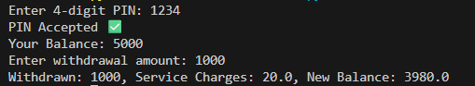
# Q2. Grocery Store Inventory System
def grocery_store():
items = {
"apple": {"stock": 10, "price": 50},
"milk": {"stock": 20, "price": 30},
"bread": {"stock": 15, "price": 40}
}
bill = 0

while True:
print("\nAvailable items:")
for item, info in items.items():
print(f"{item.capitalize()} - Rs.{info['price']} (Stock: {info['stock']})")

choice = input("\nEnter item name (or 'done' to finish): ").lower()
if choice == "done":
break

if choice in items:
try:
qty = int(input("Enter quantity: "))
if qty <= 0:
print("Quantity must be positive ❌")
continue

if items[choice]["stock"] >= qty:
cost = items[choice]["price"] * qty
items[choice]["stock"] -= qty
bill += cost
print(f"Added {qty} {choice}(s) → Rs.{cost}")
else:
print("Insufficient stock ❌")
except ValueError:
print("Invalid quantity ❌")
else:
print("Item not available ❌")

# Apply discount
if bill > 500:
discount = 0.2
elif bill > 300:
discount = 0.15
elif bill > 100:
discount = 0.1
else:
discount = 0

bill -= bill * discount
tax = bill * 0.05
final_bill = bill + tax

print(f"\nFinal Bill: Rs.{final_bill:.2f} (including 5% tax)")

# ✅ Function call (important, warna kuch run nahi hoga)
grocery_store()
Output
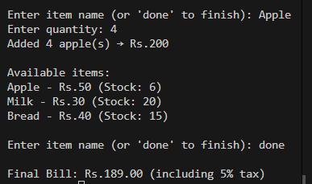
# Q3. Student Grading with Subject Weightage
def student_grading():
weights = (0.1, 0.2, 0.25, 0.2, 0.25)
marks = []
for i in range(5):
marks.append(int(input(f"Enter marks for subject {i+1}: ")))
weighted = sum(m * w for m, w in zip(marks, weights))
print(f"Weighted % = {weighted}")
if weighted >= 80:
grade, scholarship = "A", "Eligible"
elif weighted >= 70:
grade, scholarship = "B", "Not Eligible"
elif weighted >= 60:
grade, scholarship = "C", "Not Eligible"
elif weighted >= 50:
grade, scholarship = "D", "Not Eligible"
else:
grade, scholarship = "Fail", "Not Eligible"
print(f"Grade: {grade}, Scholarship: {scholarship}")
student_grading()
Output
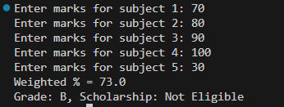
# Q4. BMI + Health Recommendation
def bmi_health():
w = float(input("Enter weight(kg): "))
h = float(input("Enter height(m): "))
age = int(input("Enter age: "))
bmi = w / (h**2)
print(f"BMI = {bmi:.2f}")
if bmi < 18.5:
print("Underweight. Eat protein & exercise.")
elif bmi < 25:
print("Normal. Maintain balanced diet.")
elif bmi < 30:
print("Overweight. Exercise daily.")
else:
print("Obese. Follow strict diet + workout.")
if age > 50 and bmi > 30:
print("⚠ Special Care Needed.")
Output
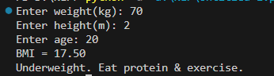
# Q5. Telecom Prepaid Recharge System
def telecom():
rates = {"call": 1, "sms": 0.5, "data": 2} # per min, per sms, per MB
balance = 200
init_balance = balance
call = int(input("Minutes used: ")) * rates["call"]
sms = int(input("SMS used: ")) * rates["sms"]
data = int(input("MB used: ")) * rates["data"]
total = call + sms + data
balance -= total
print(f"Remaining Balance: {balance}")
if balance < 0.2 * init_balance:
print("Recharge Reminder ⚡")
recharge = int(input("Enter recharge amount: "))
balance += recharge
if recharge > 1000:
balance += 100
print("🎁 Bonus 100 added")
print(f"Final Balance: {balance}")
Output
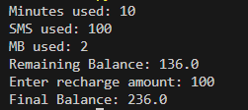

# Q6. E-Commerce Discount Engine
def ecommerce():
bill = float(input("Enter bill amount: "))
member = input("Membership (Regular/Gold/Platinum): ").lower()
if member == "gold":
bill -= bill * 0.1
elif member == "platinum":
bill -= bill * 0.15
if bill > 10000:
bill -= bill * 0.05
tax = bill * 0.05
print(f"Final Bill: {bill+tax}, Tax: {tax}")
Output
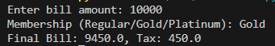
# Q7. Hospital Emergency Unit
def hospital():
t = float(input("Temp: "))
p = int(input("Pulse: "))
o2 = int(input("Oxygen: "))
bp = int(input("BP: "))
if o2 < 85 or bp < 80:
print("Critical → Admit in ICU")
elif o2 < 92 or bp < 90:
print("Urgent → Immediate doctor attention")
elif t > 100 or p > 100:
print("Observation needed")
else:
print("Stable")
Output
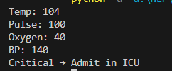
# Q8. Online Examination Grader
def exam():
total = int(input("Total Marks: "))
obtained = int(input("Obtained: "))
wrong = int(input("Wrong Answers: "))
obtained -= wrong * 0.25
percent = (obtained / total) * 100
if percent >= 80:
div, scholar = "1st Division", "Scholarship Eligible"
elif percent >= 60:
div, scholar = "2nd Division", "Not Eligible"
elif percent >= 40:
div, scholar = "3rd Division", "Not Eligible"
else:
print("Fail → Repeat Exam")
return
print(f"Division: {div}, Scholarship: {scholar}")
Output
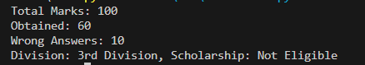

# Q9. Movie Ticket Booking
def movie_ticket():
base = {"normal": 300, "3d": 500, "imax": 800}
age = int(input("Age: "))
show = int(input("Showtime(24hr): "))
ttype = input("Type (Normal/3D/IMAX): ").lower()
price = base[ttype]
if age < 12 and show > 20:
print("Children not allowed at late night")
return
if age > 60:
price -= price * 0.3
if 18 <= show <= 22:
price += price * 0.1
print(f"Ticket Price: {price}")
Output
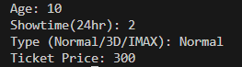

# Q10. Weather-based Outfit
def outfit():
temp = int(input("Temperature: "))
weather = input("Weather (Rainy/Sunny/Cold): ").lower()
event = input("Event (Casual/Business/Party): ").lower()
if weather == "rainy":
print("Take an umbrella ☔")
if weather == "cold":
print("Wear gloves 🧤")
if event == "business" and temp > 35:
print("Wear light formal suit")
else:
print("Dress comfortably for", event)
Output
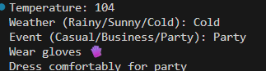
# Q11. ATM Withdrawal with Note Counting
def atm_withdraw():
balance = 10000
amount = int(input("Enter withdrawal: "))
if amount > balance:
print("Insufficient Funds")
return
notes = {}
for n in [1000, 500, 100, 50, 10, 1]:
notes[n], amount = divmod(amount, n)
charge = amount * 0.005
balance -= (amount + charge)
print("Notes:", notes)
print(f"Remaining Balance: {balance}")
Output
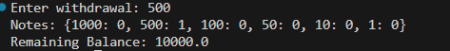
# Q12. Library Fine Calculator
def library():
days = int(input("Days late: "))
member = input("Premium member? (y/n): ")
if days > 30:
print("Membership Cancelled")
return
fine = 0
if days <= 10:
fine = days * 10
elif days <= 20:
fine = days * 20
else:
fine = days * 50
if member == "y":
fine /= 2
print(f"Fine: {fine}")
Output
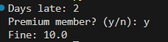

# Q13. Sales Analysis Dashboard
def sales():
sales = [int(input(f"Enter sales for month {i+1}: ")) for i in range(12)]
avg = sum(sales)/12
print("Max:", max(sales), "Min:", min(sales), "Avg:", avg)
for i, val in enumerate(sales):
if val > avg:
print(f"Month {i+1} above average")
if i > 0:
if val > sales[i-1]:
print(f"Month {i+1}: Growth")
else:
print(f"Month {i+1}: Decline")

Output
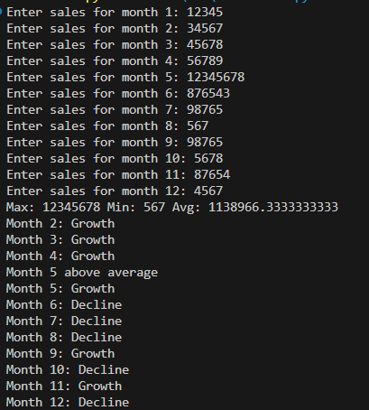

# Q14. Multiplication Puzzle
import random
def puzzle():
score = 0
table = {i: i*5 for i in range(1,11)}
blanks = random.sample(list(table.keys()),3)
for k in blanks:
ans = int(input(f"5 x {k} = ?? "))
if ans == table[k]:
score += 1
print("Score:", score)
if score == 3: print("Excellent")
elif score == 2: print("Good")
else: print("Try Again")
Output
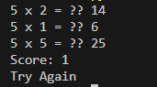
# Q15. Password Strength
import re
def password_check():
attempts = 0
while attempts < 3:
pwd = input("Enter password: ")
if (len(pwd)>=8 and re.search("[A-Z]",pwd) and re.search("[a-z]",pwd)
and re.search("[0-9]",pwd) and re.search("[^A-Za-z0-9]",pwd)):
print("Strong Password ✅")
return
else:
print("Weak Password ❌")
attempts += 1
print("Account Locked 🚫")
Output
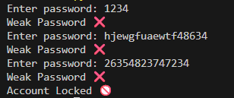
# Q16. Electricity Bill
def calculate_bill(units, late=False):
if units <= 100:
amt = units*5
elif units <= 200:
amt = 100*5 + (units-100)*7
else:
amt = 100*5 + 100*7 + (units-200)*10
if late:
amt += amt*0.15
print(f"Bill = {amt}")
Output

Q17 win prediction
def predict_score(runs, balls, wickets, overs_left):
run_rate = runs / (20-overs_left)
if run_rate < 5 and wickets > 6:
print("Losing")
elif run_rate > 7 and wickets < 5:
print("Winning")
else:
print("Balanced")
predict_score(int(input("Runs: ")), int(input("Balls: ")), int(input("Wickets: ")), int(input("Overs left: ")))
Output


Q18. Hotel Billing
def book_room(type, days, is_member):
price = {"standard":2000,"deluxe":4000,"suite":6000}[type]
cost = price*days
if days>7: cost*=0.8
if is_member: cost*=0.9
tax = cost*0.12
print(f"Final Bill: {cost+tax}")
book_room(input("Room Type (standard/deluxe/suite): ").lower(), int(input("Number of days: ")), input("Loyalty member? (y/n): ")=="y")
Output
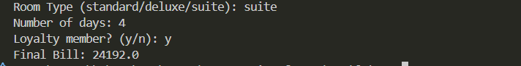
# Q19. Flight Fare Calculator
def calculate_fare(distance, ctype, intl=False, advance=False):
rates = {"economy":10,"business":25,"first":40}
fare = distance*rates[ctype]+500
if intl: fare += fare*0.18
if advance: fare *=0.9
print("Fare:",fare)
calculate_fare(int(input("Distance (km): ")), input("Class (economy/business/first): ").lower(), input("International? (y/n): ")=="y", input("Advance booking? (y/n): ")=="y")
Output
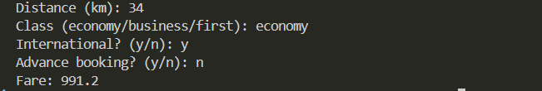

# Q20. Smart Vending Machine
def vending_machine():
items = {"chips":{"stock":5,"price":50},"coke":{"stock":3,"price":100}}
wallet = 200
choice = input("Enter item: ")
if choice in items and items[choice]["stock"]>0:
price = items[choice]["price"]
if wallet>=price:
items[choice]["stock"]-=1
wallet -= price
print(f"Dispensed {choice}, Wallet Balance={wallet}")
else:
print("Insufficient balance ❌")
else:
print("Out of stock")
vending_machine()
Output

LAB 2
Question # 1: Create a `BankAccount` class that represents a bank account. It should have attributes for account number, account holder name, and balance. Include methods to deposit, withdraw, and display balance. Ensure withdrawals cannot exceed the available balance.
class BankAccount:
def __init__(self, account_number, holder_name, balance=0):
self.account_number = account_number
self.holder_name = holder_name
self.balance = balance

def deposit(self, amount):
if amount > 0:
self.balance += amount
print(f"Deposited: {amount}")
else:
print("Deposit amount must be positive.")

def withdraw(self, amount):
if amount > self.balance:
print("Insufficient balance!")
elif amount <= 0:
print("Withdrawal amount must be positive.")
else:
self.balance -= amount
print(f"Withdrawn: {amount}")

def display_balance(self):
print(f"Account Holder: {self.holder_name}")
print(f"Account Number: {self.account_number}")
print(f"Current Balance: {self.balance}")

account1 = BankAccount("12345", "Hamza", 1000)

account1.deposit(500)
account1.withdraw(300)
account1.withdraw(1500) # Should show insufficient balance
account1.display_balance()

OUTPUT
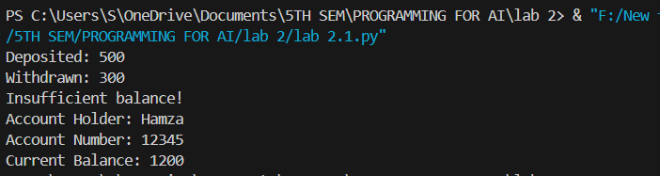
Question # 2: Design a `Book` class with attributes like title, author, ISBN, and availability status. Create a `Library` class that can add books, search for books by title/author, check out books, and return books. Track which books are currently available.
class Book:
def __init__(self, title, author, isbn):
self.title = title
self.author = author
self.isbn = isbn
self.available = True # book is available by default

def check_out(self):
if self.available:
self.available = False
print(f"'{self.title}' has been checked out.")
else:
print(f"'{self.title}' is not available right now.")

def return_book(self):
self.available = True
print(f"'{self.title}' has been returned and is now available.")

def display_info(self):
status = "Available" if self.available else "Not Available"
print(f"Title: {self.title}, Author: {self.author}, ISBN: {self.isbn}, Status: {status}")

class Library:
def __init__(self):
self.books = [] # list to store all books

def add_book(self, book):
self.books.append(book)
print(f"Book '{book.title}' added to the library.")

def search_by_title(self, title):
print(f"\nSearching for title: {title}")
for book in self.books:
if book.title.lower() == title.lower():
book.display_info()
return
print("Book not found.")

def search_by_author(self, author):
print(f"\nBooks by {author}:")
found = False
for book in self.books:
if book.author.lower() == author.lower():
book.display_info()
found = True
if not found:
print("No books found by that author.")

def check_out_book(self, title):
for book in self.books:
if book.title.lower() == title.lower():
book.check_out()
return
print("Book not found.")

def return_book(self, title):
for book in self.books:
if book.title.lower() == title.lower():
book.return_book()
return
print("Book not found.")

library = Library()

book1 = Book("dard", "John Elia", "12345")
book2 = Book("peer e kamil", "faraz", "67890")

library.add_book(book1)
library.add_book(book2)

library.search_by_title("peer e kamil")
library.check_out_book("peer e kamil")
library.search_by_title("peer e kamil")
library.return_book("peer e kamil")
library.search_by_author("John elia")
OUTUT
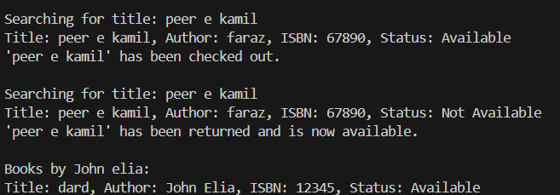
Question # 3: Create a `Student` class with attributes for student ID, name, and a list of grades. Implement methods to add grades, calculate average grade, and determine the letter grade (A, B, C, etc.). Add a method to display student information with their performance summary.
class Student:
def __init__(self, student_id, name):
self.student_id = student_id
self.name = name
self.grades = [] # list to store all grades

def add_grade(self, grade):
if 0 <= grade <= 100:
self.grades.append(grade)
print(f"Grade {grade} added for {self.name}.")
else:
print("Grade must be between 0 and 100.")

def calculate_average(self):
if len(self.grades) == 0:
return 0
return sum(self.grades) / len(self.grades)

def get_letter_grade(self):
avg = self.calculate_average()
if avg >= 90:
return "A"
elif avg >= 80:
return "B"
elif avg >= 70:
return "C"
elif avg >= 60:
return "D"
else:
return "F"

def display_info(self):
average = self.calculate_average()
letter = self.get_letter_grade()
print("\n--- Student Performance Summary ---")
print(f"Student ID: {self.student_id}")
print(f"Name: {self.name}")
print(f"Grades: {self.grades}")
print(f"Average: {average:.2f}")
print(f"Letter Grade: {letter}")

# Example usage
student1 = Student("S001", "Hamza")

student1.add_grade(85)
student1.add_grade(90)
student1.add_grade(78)

student1.display_info()

student2 = Student("S002", "Ali")

student2.add_grade(95)
student2.add_grade(92)
student2.add_grade(88)

student2.display_info()
OUTPUT
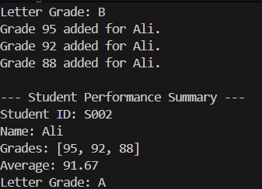
Question # 4: Design a `MenuItem` class for food items (name, price, category) and an `Order` class that can add multiple items, calculate total cost, apply discounts, and generate receipts. Include tax calculation functionality.
class MenuItem:
def __init__(self, name, price, category):
self.name = name
self.price = price
self.category = category

def display_item(self):
print(f"{self.name} ({self.category}) - Rs.{self.price}")

class Order:
def __init__(self):
self.items = [] # list to store menu items

def add_item(self, item):
self.items.append(item)
print(f"Added: {item.name} - Rs.{item.price}")

def calculate_total(self):
total = sum(item.price for item in self.items)
return total

def apply_discount(self, total, discount_percent):
discount = total * (discount_percent / 100)
return total - discount

def calculate_tax(self, total, tax_percent):
tax = total * (tax_percent / 100)
return total + tax

def generate_receipt(self, discount_percent=0, tax_percent=5):
print("\n--- Receipt ---")
for item in self.items:
item.display_item()

subtotal = self.calculate_total()
print(f"\nSubtotal: Rs.{subtotal:.2f}")

if discount_percent > 0:
subtotal = self.apply_discount(subtotal, discount_percent)
print(f"After {discount_percent}% discount: Rs.{subtotal:.2f}")

total_with_tax = self.calculate_tax(subtotal, tax_percent)
print(f"After {tax_percent}% tax: Rs.{total_with_tax:.2f}")

print("\nThank you for your order!")

# Example usage
item1 = MenuItem("Burger", 350, "Fast Food")
item2 = MenuItem("Pizza", 800, "Fast Food")
item3 = MenuItem("Cold Drink", 150, "Beverage")

order1 = Order()
order1.add_item(item1)
order1.add_item(item2)
order1.add_item(item3)

order1.generate_receipt(discount_percent=10, tax_percent=8)

OUTPUT
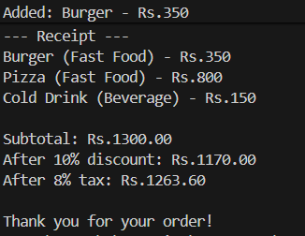

Question # 5: Create classes for `Vehicle` (base class) and derived classes `Car`, `Motorcycle`, and `Truck`. Each vehicle should have attributes like license plate, model, rental price per day, and availability. Implement a system to rent vehicles and calculate rental costs.
class Vehicle:
def __init__(self, license_plate, model, price_per_day):
self.license_plate = license_plate
self.model = model
self.price_per_day = price_per_day
self.available = True # all vehicles are available at first

def rent(self, days):
if self.available:
cost = self.price_per_day * days
self.available = False
print(f"{self.model} (Plate: {self.license_plate}) rented for {days} days.")
print(f"Total cost: Rs.{cost}")
else:
print(f"{self.model} is not available right now.")

def return_vehicle(self):
self.available = True
print(f"{self.model} has been returned and is now available.")

def display_info(self):
status = "Available" if self.available else "Not Available"
print(f"Model: {self.model}, Plate: {self.license_plate}, Price/Day: Rs.{self.price_per_day}, Status: {status}")

# Derived classes
class Car(Vehicle):
def __init__(self, license_plate, model, price_per_day, seats):
super().__init__(license_plate, model, price_per_day)
self.seats = seats

def display_info(self):
super().display_info()
print(f"Seats: {self.seats}")

class Motorcycle(Vehicle):
def __init__(self, license_plate, model, price_per_day, engine_cc):
super().__init__(license_plate, model, price_per_day)
self.engine_cc = engine_cc

def display_info(self):
super().display_info()
print(f"Engine: {self.engine_cc}cc")

class Truck(Vehicle):
def __init__(self, license_plate, model, price_per_day, load_capacity):
super().__init__(license_plate, model, price_per_day)
self.load_capacity = load_capacity

def display_info(self):
super().display_info()
print(f"Load Capacity: {self.load_capacity} tons")

# Example usage
car1 = Car("ABC-123", "Toyota Corolla", 5000, 5)
bike1 = Motorcycle("XYZ-789", "Honda 125", 1500, 125)
truck1 = Truck("TRK-555", "Hino", 10000, 10)

# Display vehicle info
print("\n--- Vehicle Information ---")
car1.display_info()
bike1.display_info()
truck1.display_info()

# Rent and return vehicles
print("\n--- Renting Vehicles ---")
car1.rent(3)
bike1.rent(2)
car1.rent(1) # Try renting again to show it's unavailable

print("\n--- Returning Vehicles ---")
car1.return_vehicle()
car1.display_info()
OUTPUT
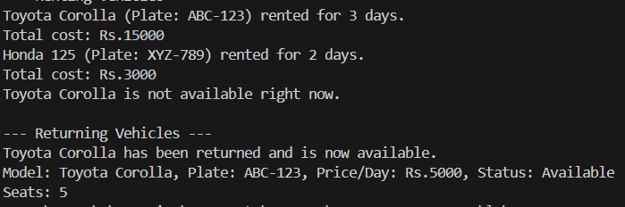
Question # 6: Design an `Employee` class with attributes for employee ID, name, position, and salary. Create methods to calculate monthly salary, annual salary, and apply raises. Include functionality to track employee details and employment duration
from datetime import date

class Employee:
def __init__(self, emp_id, name, position, salary, start_year):
self.emp_id = emp_id
self.name = name
self.position = position
self.salary = salary # annual salary
self.start_year = start_year

def monthly_salary(self):
return self.salary / 12

def annual_salary(self):
return self.salary

def apply_raise(self, percent):
if percent > 0:
increase = self.salary * (percent / 100)
self.salary += increase
print(f"Salary increased by {percent}%. New annual salary: Rs.{self.salary:.2f}")
else:
print("Raise percentage must be positive.")

def employment_duration(self):
current_year = date.today().year
return current_year - self.start_year

def display_info(self):
print("\n--- Employee Details ---")
print(f"Employee ID: {self.emp_id}")
print(f"Name: {self.name}")
print(f"Position: {self.position}")
print(f"Annual Salary: Rs.{self.salary:.2f}")
print(f"Monthly Salary: Rs.{self.monthly_salary():.2f}")
print(f"Years of Service: {self.employment_duration()} years")

# Example usage
emp1 = Employee("E101", "Hamza Sheikh", "Software Engineer", 1200000, 2020)
emp2 = Employee("E102", "Ali Raza", "Accountant", 800000, 2022)

emp1.display_info()
emp2.display_info()

# Applying a raise
emp1.apply_raise(10)
emp1.display_info()

# Applying a negative raise
emp2.apply_raise(-5)
emp2.display_info()

OUTPUT
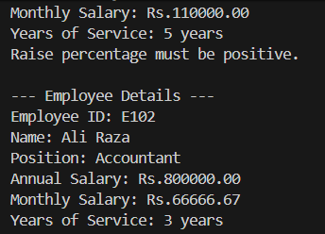

Question # 7:Create a `Product` class with attributes for product ID, name, price, and stock quantity. Design a `ShoppingCart` class that can add products, remove products, calculate total cost, and handle checkout process while updating inventory.
class Product:
def __init__(self, product_id, name, price, stock):
self.product_id = product_id
self.name = name
self.price = price
self.stock = stock

def update_stock(self, quantity):
if quantity <= self.stock:
self.stock -= quantity
else:
print(f"Not enough stock for {self.name}!")

def display_info(self):
print(f"Product ID: {self.product_id}, Name: {self.name}, Price: Rs.{self.price}, Stock: {self.stock}")

class ShoppingCart:
def __init__(self):
self.items = {} # {product: quantity}

def add_product(self, product, quantity):
if product.stock >= quantity:
if product in self.items:
self.items[product] += quantity
else:
self.items[product] = quantity
product.update_stock(quantity)
print(f"Added {quantity} x {product.name} to the cart.")
else:
print(f"Only {product.stock} units of {product.name} available.")

def remove_product(self, product):
if product in self.items:
removed_qty = self.items.pop(product)
product.stock += removed_qty # return stock to inventory
print(f"Removed {product.name} from the cart.")
else:
print("Product not found in cart.")

def calculate_total(self):
total = sum(product.price * qty for product, qty in self.items.items())
return total

def checkout(self):
if not self.items:
print("Cart is empty! Add some products first.")
return
total = self.calculate_total()
print("\n--- Checkout Summary ---")
for product, qty in self.items.items():
print(f"{product.name} x{qty} = Rs.{product.price * qty}")
print(f"Total Amount: Rs.{total}")
self.items.clear()
print("Checkout complete. Thank you for shopping!")

# Example usage
p1 = Product("P101", "Laptop", 150000, 5)
p2 = Product("P102", "Mouse", 2000, 10)
p3 = Product("P103", "Keyboard", 5000, 8)

cart = ShoppingCart()

# Display available products
print("\n--- Product List ---")
p1.display_info()
p2.display_info()
p3.display_info()

# Add products to cart
print("\n--- Adding to Cart ---")
cart.add_product(p1, 1)
cart.add_product(p2, 2)
cart.add_product(p3, 1)

# Remove a product
cart.remove_product(p2)

# Checkout
cart.checkout()

# Check updated stock
print("\n--- Updated Inventory ---")
p1.display_info()
p2.display_info()
p3.display_info()

OUTPUT
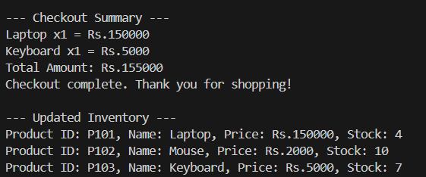
Question # 8: Design a `Patient` class to store patient information (ID, name, age, medical history) and an `Appointment` class to manage doctor appointments. Include functionality to schedule, cancel, and view appointments.
class Patient:
def __init__(self, patient_id, name, age):
self.patient_id = patient_id
self.name = name
self.age = age
self.medical_history = []

def add_medical_record(self, record):
self.medical_history.append(record)
print(f"Medical record added for {self.name}: {record}")

def display_info(self):
print("\n--- Patient Information ---")
print(f"Patient ID: {self.patient_id}")
print(f"Name: {self.name}")
print(f"Age: {self.age}")
print(f"Medical History: {', '.join(self.medical_history) if self.medical_history else 'No records'}")

class Appointment:
def __init__(self):
self.appointments = [] # List to store all appointments

def schedule_appointment(self, patient, doctor_name, date, time):
appointment = {
"patient": patient,
"doctor": doctor_name,
"date": date,
"time": time
}
self.appointments.append(appointment)
print(f"Appointment scheduled for {patient.name} with Dr. {doctor_name} on {date} at {time}.")

def cancel_appointment(self, patient_id):
for appointment in self.appointments:
if appointment["patient"].patient_id == patient_id:
self.appointments.remove(appointment)
print(f"Appointment for {appointment['patient'].name} has been canceled.")
return
print("No appointment found for this patient ID.")

def view_appointments(self):
if not self.appointments:
print("\nNo appointments scheduled.")
return

print("\n--- Scheduled Appointments ---")
for app in self.appointments:
print(f"Patient: {app['patient'].name}, Doctor: Dr. {app['doctor']}, Date: {app['date']}, Time: {app['time']}")

# Example usage
p1 = Patient("P001", "Hamza Sheikh", 25)
p2 = Patient("P002", "Ali Raza", 30)

p1.add_medical_record("Flu treatment - Jan 2024")
p2.add_medical_record("Blood test - Mar 2024")

p1.display_info()
p2.display_info()

appointment_system = Appointment()
appointment_system.schedule_appointment(p1, "Dr. Ahmed", "2025-10-15", "10:30 AM")
appointment_system.schedule_appointment(p2, "Dr. Sara", "2025-10-16", "11:00 AM")

appointment_system.view_appointments()

appointment_system.cancel_appointment("P001")

appointment_system.view_appointments()

OUTPUT
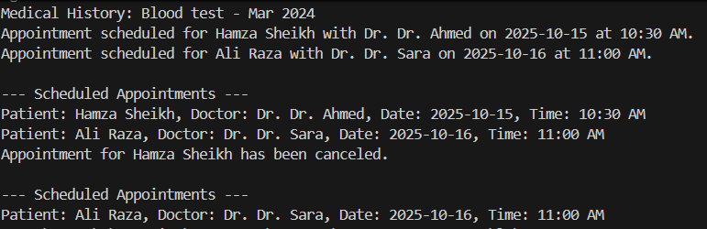

Question # 9: Create a `User` class for a social media platform with attributes for username, email, friends list, and posts. Implement methods to add friends, create posts, and display user timeline. Include privacy settings for posts.
class Post:
def __init__(self, content, privacy="Public"):
self.content = content
self.privacy = privacy # "Public" or "Friends Only"

def display_post(self, viewer_is_friend):
if self.privacy == "Public" or viewer_is_friend:
return self.content
else:
return "[Private Post]"

class User:
def __init__(self, username, email):
self.username = username
self.email = email
self.friends = [] # list of User objects
self.posts = [] # list of Post objects

def add_friend(self, user):
if user not in self.friends:
self.friends.append(user)
user.friends.append(self) # friendship is two-way
print(f"{self.username} and {user.username} are now friends.")
else:
print(f"{user.username} is already a friend.")

def create_post(self, content, privacy="Public"):
post = Post(content, privacy)
self.posts.append(post)
print(f"Post created by {self.username} ({privacy}).")

def display_timeline(self, viewer):
print(f"\n--- {self.username}'s Timeline ---")
for post in self.posts:
is_friend = viewer in self.friends or viewer == self
print(f"- {post.display_post(is_friend)}")

# Example usage
user1 = User("Hashir", "hamza@example.com")
user2 = User("Ali", "ali@example.com")
user3 = User("Sara", "sara@example.com")

# Make friends
user1.add_friend(user2)

# Create posts
user1.create_post("Hello everyone! This is my first post.", "Public")
user1.create_post("Hanging out with friends today!", "Friends Only")

# View timelines
user1.display_timeline(user1) # viewing own timeline
user1.display_timeline(user2) # friend can see private posts
user1.display_timeline(user3) # not a friend, can't see private posts

OUTPUT
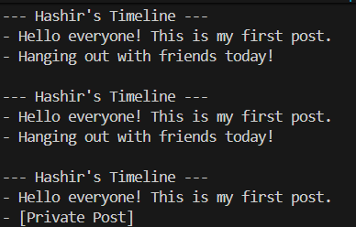

Question # 10: Design a `Room` class with room number, type (single/double/suite), price, and availability. Create a `Booking` class to handle room reservations, check-in/check-out dates, and calculate total stay cost.
class Room:
def __init__(self, room_number, room_type, price):
self.room_number = room_number
self.room_type = room_type
self.price = price
self.available = True # All rooms start as available

def display_info(self):
status = "Available" if self.available else "Booked"
print(f"Room {self.room_number} ({self.room_type}) - Rs.{self.price}/night - {status}")

class Booking:
def __init__(self):
self.bookings = [] # list to store booking details

def book_room(self, room, guest_name, check_in, check_out, nights):
if room.available:
total_cost = room.price * nights
booking_info = {
"room": room,
"guest_name": guest_name,
"check_in": check_in,
"check_out": check_out,
"nights": nights,
"total_cost": total_cost
}
self.bookings.append(booking_info)
room.available = False
print(f"\nRoom {room.room_number} booked for {guest_name}.")
print(f"Check-in: {check_in}, Check-out: {check_out}")
print(f"Total cost: Rs.{total_cost}")
else:
print(f"Room {room.room_number} is not available right now.")

def check_out(self, room_number):
for booking in self.bookings:
if booking["room"].room_number == room_number:
booking["room"].available = True
print(f"\n{booking['guest_name']} has checked out from Room {room_number}.")
self.bookings.remove(booking)
return
print("No active booking found for this room.")

def view_bookings(self):
if not self.bookings:
print("\nNo current bookings.")
return
print("\n--- Current Bookings ---")
for b in self.bookings:
print(f"Room {b['room'].room_number} | Guest: {b['guest_name']} | "
f"Stay: {b['check_in']} to {b['check_out']} | Total: Rs.{b['total_cost']}")

# Example usage
room1 = Room(101, "Single", 5000)
room2 = Room(102, "Double", 8000)
room3 = Room(201, "Suite", 12000)

print("\n--- Available Rooms ---")
room1.display_info()
room2.display_info()
room3.display_info()

# Booking system
hotel = Booking()
hotel.book_room(room1, "Hashir", "2025-10-14", "2025-10-17", 3)
hotel.book_room(room2, "Ali Raza", "2025-10-15", "2025-10-18", 3)

hotel.view_bookings()

hotel.check_out(101)
hotel.view_bookings()

print("\n--- Updated Room Status ---")
room1.display_info()
room2.display_info()
room3.display_info()

OUTPUT
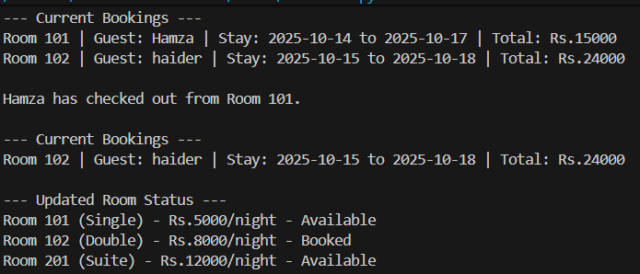

LAB 3 (NUMPY)
Question 1: A weather station records temperatures (°C) for 7 days:
import numpy as np
np.set_printoptions(precision=4, suppress=True)
temps_list = [21.1, 23.4, 19.8, 25.0, 26.5, 24.1, 22.0]
temps = np.array(temps_list)
avg_temp = temps.mean()
max_temp = temps.max()
min_temp = temps.min()
temp_range = max_temp - min_temp

print("Q1 - Temperatures array:", temps)
print("Average:", avg_temp)
print("Max:", max_temp)
print("Min:", min_temp)
print("Range:", temp_range)
print("-" * 60)

OUTPUT
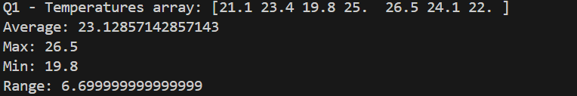Question 2: A fruit store records daily sales of apples for 4 weeks:
# -------------------------
# Question 2: Apple sales (4x7)
# -------------------------
import numpy as np
week1 = [12, 15, 14, 10, 9, 8, 7]
week2 = [11, 12, 13, 9, 5, 8, 6]
week3 = [7, 9, 12, 10, 11, 13, 12]
week4 = [10, 11, 12, 7, 8, 9, 11]

sales = np.array([week1, week2, week3, week4]) # shape (4,7)
weekly_totals = sales.sum(axis=1) # sum per week
# highest sale day (index only) -> index in the flattened array of the max,
# but more useful: index of max in each week or overall day-of-week index
overall_max_index_flat = sales.argmax() # flattened index
overall_max_week, overall_max_day = np.unravel_index(overall_max_index_flat, sales.shape)
# week with most sales
best_week_index = weekly_totals.argmax()

print("Q2 - Sales array (4x7):\n", sales)
print("Weekly totals:", weekly_totals)
print("Overall highest sale at (week_index, day_index):", (overall_max_week, overall_max_day))
print("Week with most sales (0-based index):", best_week_index)
print("-" * 60)

OUTPUT
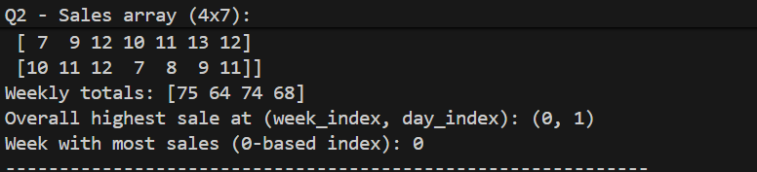

Question 3: Students received marks in a test:
# -------------------------
# Question 3: Student marks + bonus
# -------------------------
import numpy as np
marks = np.array([56, 78, 45, 90, 88, 76, 59, 62])
marks_bonus = marks + 5 # broadcasting
count_above_60 = np.sum(marks_bonus > 60)
median_marks = np.median(marks_bonus)
std_marks = np.std(marks_bonus, ddof=0) # population std by default in numpy is ddof=0

print("Q3 - Original marks:", marks)
print("Marks after +5 bonus:", marks_bonus)
print("Count > 60:", count_above_60)
print("Median:", median_marks)
print("Std dev:", std_marks)
print("-" * 60)

OUTPUT
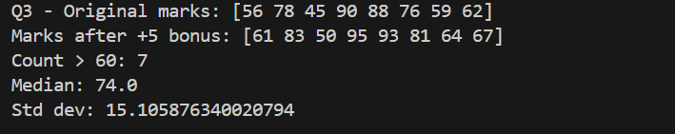
Question 4: A smartwatch stores daily step-counts for a user for 30 days.
# -------------------------
# Question 4: Step-counts (30 days)
# -------------------------
import numpy as np
rng = np.random.default_rng(seed=0)
steps_30 = rng.integers(low=2000, high=15001, size=30) # inclusive low, exclusive high
steps_matrix = steps_30.reshape(5, 6) # 5 rows x 6 cols

# Weekly average steps (treat each row as a "week")
weekly_avg = steps_matrix.mean(axis=1)
max_day_index_flat = steps_30.argmax()
max_day_number = max_day_index_flat + 1 # 1-based day number
num_days_over_10k = np.sum(steps_30 > 10000)

print("Q4 - 30 day steps (vector):", steps_30)
print("Reshaped (5x6):\n", steps_matrix)
print("Weekly averages (per row):", weekly_avg)
print("Day with max steps (1-based index):", max_day_number, "value:", steps_30[max_day_index_flat])
print("Days with > 10000 steps:", int(num_days_over_10k))
print("-" * 60)

OUTPUT
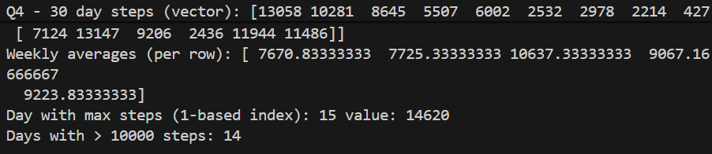

Question 5: Heart rate readings (in BPM) for 10 patients recorded 4 times per day:
# -------------------------
# Question 5: Heart rates (10 patients x 4 times)
# -------------------------
import numpy as np
rng = np.random.default_rng(seed=1)
hr = rng.integers(low=60, high=150, size=(10, 4)) # integer array (10,4)
daily_avg_per_patient = hr.mean(axis=1)
abnormal_mask = hr > 120 # True where reading > 120

overall_max_hr = hr.max()
overall_min_hr = hr.min()

print("Q5 - Heart rates (10x4):\n", hr)
print("Daily average per patient:", np.round(daily_avg_per_patient, 2))
print("Abnormal readings (>120) mask:\n", abnormal_mask)
print("Overall max HR:", overall_max_hr)
print("Overall min HR:", overall_min_hr)
print("-" * 60)

OUTPUT
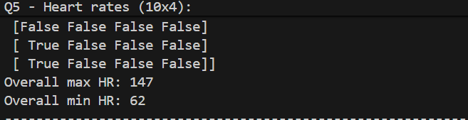

Question 6: Two branches of a store record monthly sales (in thousands):
# -------------------------
# Question 6: Branch monthly sales
# -------------------------
import numpy as np
A = np.array([122, 135, 150, 160, 155, 140])
B = np.array([110, 130, 148, 165, 158, 145])

diff = A - B
avg_A = A.mean()
avg_B = B.mean()
better_branch = "A" if A.sum() > B.sum() else ("B" if B.sum() > A.sum() else "Tie")
# correlation (Pearson) between A and B
corr_coeff = np.corrcoef(A, B)[0, 1]

print("Q6 - Branch A:", A)
print("Branch B:", B)
print("Difference (A - B):", diff)
print("Avg A:", avg_A, "Avg B:", avg_B)
print("Better overall:", better_branch)
print("Correlation coefficient A vs B:", corr_coeff)
print("-" * 60)

OUTPUT
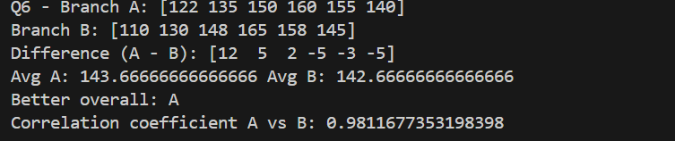

Question 7: Given a 4×4 grayscale image:
# -------------------------
# Question 7: Grayscale image 4x4
# -------------------------
import numpy as np
img = np.array([
[100, 120, 130, 90],
[80 , 110, 140, 100],
[70 , 90 , 120, 130],
[110, 140, 150, 160]
], dtype=np.float64)

# Normalize 0-1
img_norm = img / 255.0
# transform
img_transformed = img * 1.2
# clip >255
img_transformed_clipped = np.clip(img_transformed, None, 255)
avg_before = img.mean()
avg_after = img_transformed_clipped.mean()

print("Q7 - Original image:\n", img)
print("Normalized (0-1):\n", np.round(img_norm, 4))
print("Transformed (x1.2) clipped to 255:\n", img_transformed_clipped)
print("Average brightness before:", avg_before)
print("Average brightness after:", avg_after)
print("-" * 60)

OUTPUT
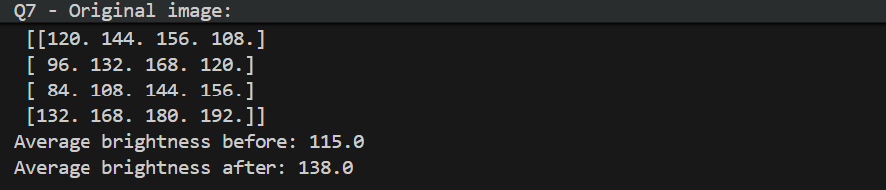

Question 8: Dataset contains 100 samples with 4 features each.
# -------------------------
# Question 8: Dataset 100x4, standardize
# -------------------------
import numpy as np
rng = np.random.default_rng(seed=2)
# generate random integers 1..100 inclusive
X = rng.integers(1, 101, size=(100, 4)).astype(float)

# standardize column-wise
means = X.mean(axis=0)
stds = X.std(axis=0, ddof=0) # population std
X_scaled = (X - means) / stds

col_means = X_scaled.mean(axis=0)
col_vars = X_scaled.var(axis=0, ddof=0)

print("Q8 - X shape:", X.shape)
print("Column means (original):", np.round(means, 4))
print("Column stds (original):", np.round(stds, 4))
print("Column means after scaling (should be ~0):", np.round(col_means, 6))
print("Column variances after scaling (should be ~1):", np.round(col_vars, 6))
print("-" * 60)

OUTPUT
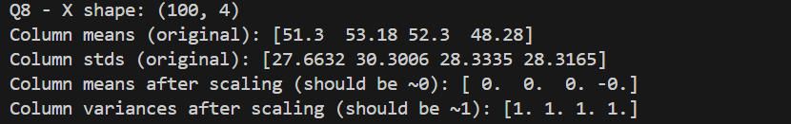

Question 9: Simulate traffic density (cars per minute) recorded by 6 sensors over 24 hours.
# -------------------------
# Question 9: Traffic density (24 hours x 6 sensors)
# -------------------------
import numpy as np
rng = np.random.default_rng(seed=3)
traffic = rng.integers(low=0, high=101, size=(24, 6)) # cars per minute (0-100)
hourly_avg = traffic.mean(axis=1) # average across sensors each hour
sensor_totals = traffic.sum(axis=0)
busiest_sensor_index = sensor_totals.argmax()

# apply cap: replace values above 50 with 50
traffic_capped = np.minimum(traffic, 50) # cap at 50
energy = (traffic_capped * 0.5).sum() # scalar energy

print("Q9 - Traffic shape:", traffic.shape)
print("Hourly averages (24):", np.round(hourly_avg, 2))
print("Busiest sensor (0-based index):", busiest_sensor_index, "total before cap:", sensor_totals[busiest_sensor_index])
print("Traffic after capping >50 -> 50 (sample first 5 hours):\n", traffic_capped[:5])
print("Energy (after cap) =", energy)
print("-" * 60)

OUTPUT
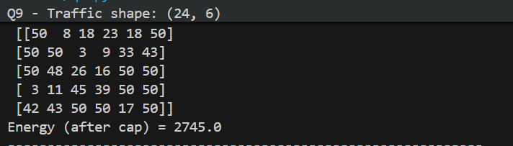

Question 10: You are simulating forces in a mechanical system.
import numpy as np
F = np.array([
[5, 2, 1],
[3, 1, 4],
[6, 3, 2],
[4, 2, 5],
[7, 1, 3]
], dtype=float)

T = np.array([
[2, 1, 0],
[1, 3, 1],
[0, 2, 2]
], dtype=float)

F_new = F.dot(T) # shape (5,3)
magnitudes = np.linalg.norm(F_new, axis=1)
highest_idx = magnitudes.argmax()

# eigen decomposition of T
eigvals, eigvecs = np.linalg.eig(T)

print("Q10 - Original F:\n", F)
print("Transformation T:\n", T)
print("Transformed forces F_new:\n", np.round(F_new, 4))
print("Magnitudes of each transformed force:", np.round(magnitudes, 4))
print("Component with highest transformed force (0-based index):", highest_idx, "magnitude:", magnitudes[highest_idx])
print("Eigenvalues of T:", np.round(eigvals, 6))
print("Eigenvectors of T (columns):\n", np.round(eigvecs, 6))
print("-" * 60)

OUTPUT :
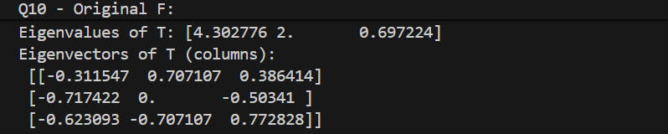
LAB 4
Question 1 :
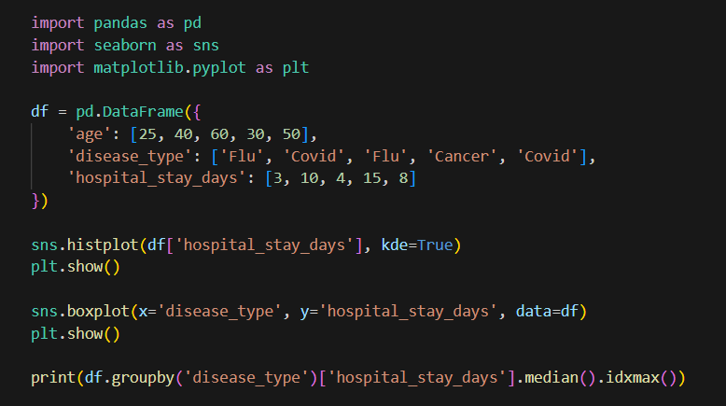
Ouput :
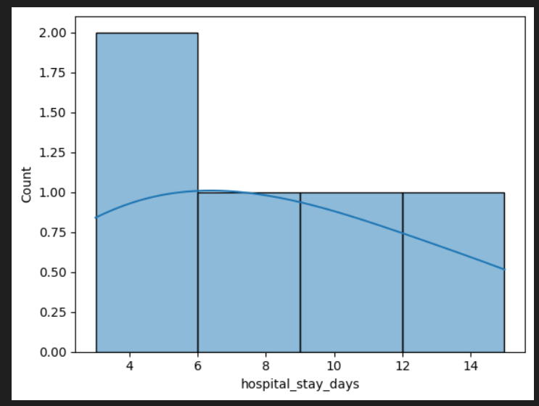
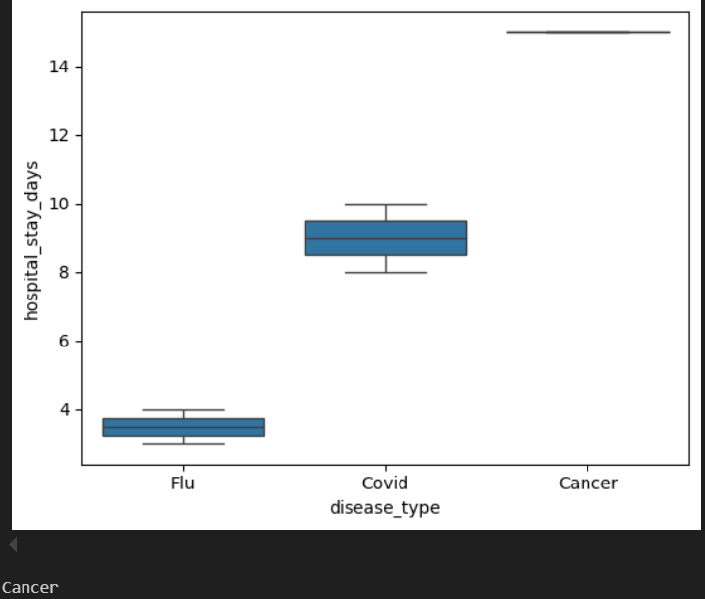

Question 2 :
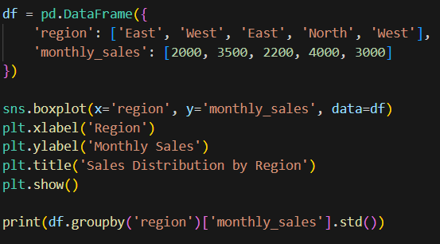
OUTPUT
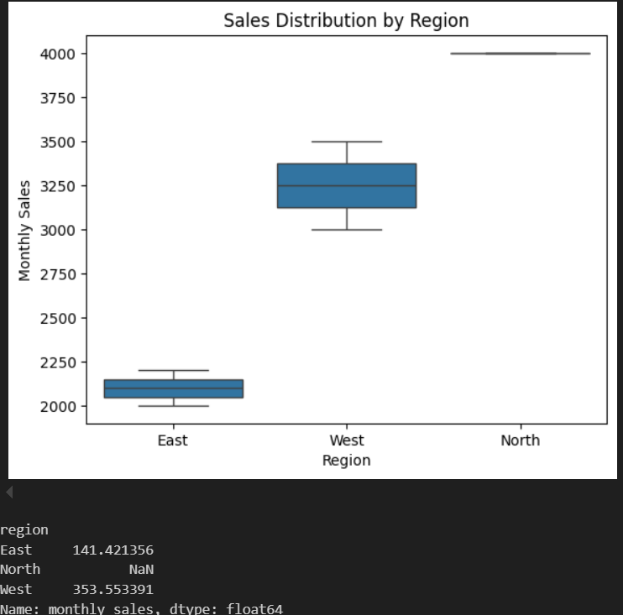

Question 3
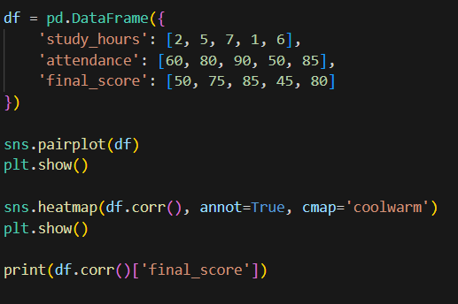
OUTPUT
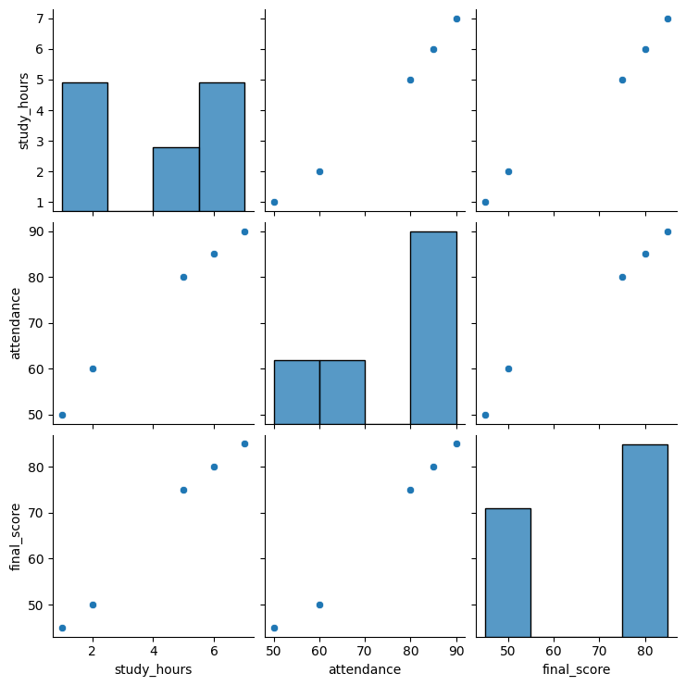

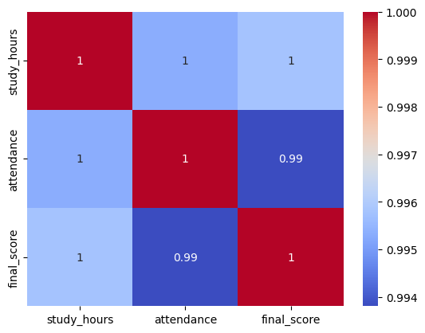
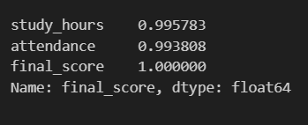

Question 4
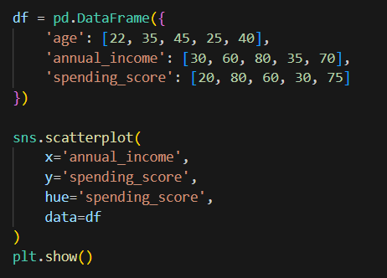
OUTPUT
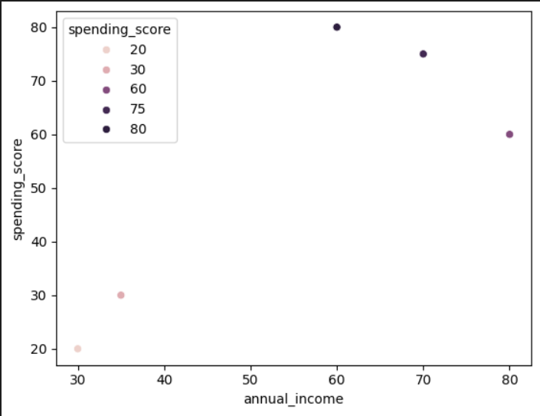

Question 5
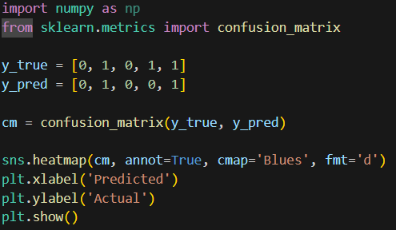
OUTPUT
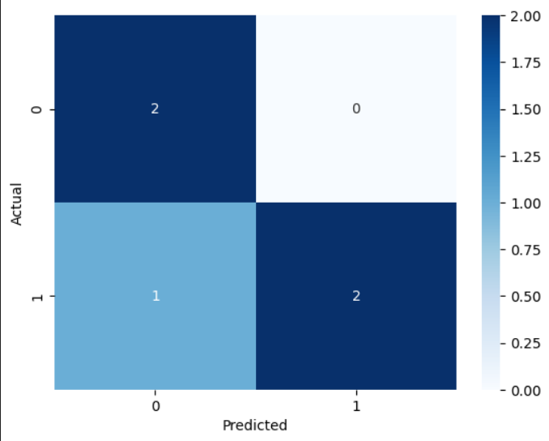

LAB 5
Question 1
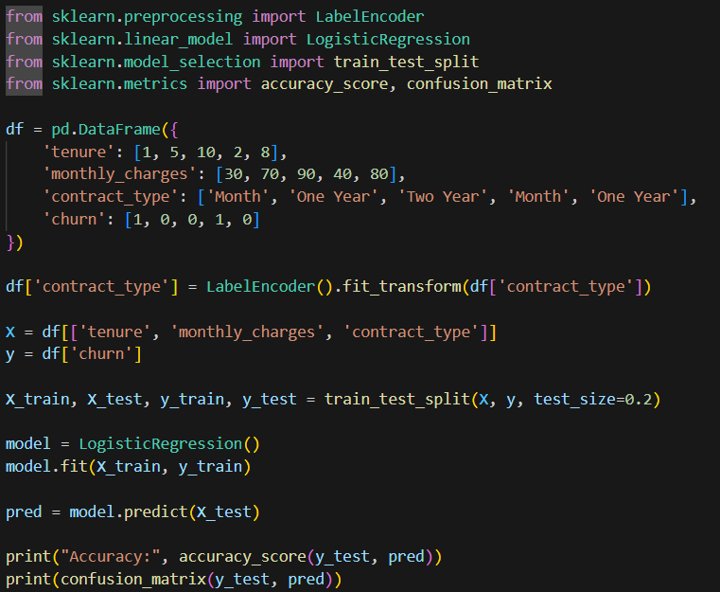
Output
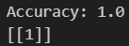

Question 2
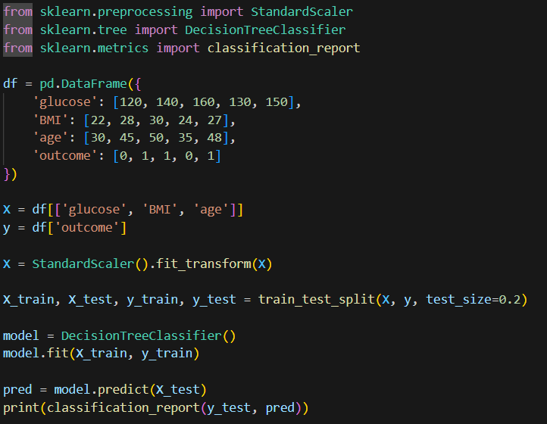
OUTPUT
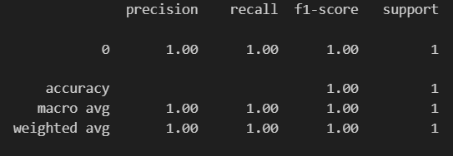

Question 3
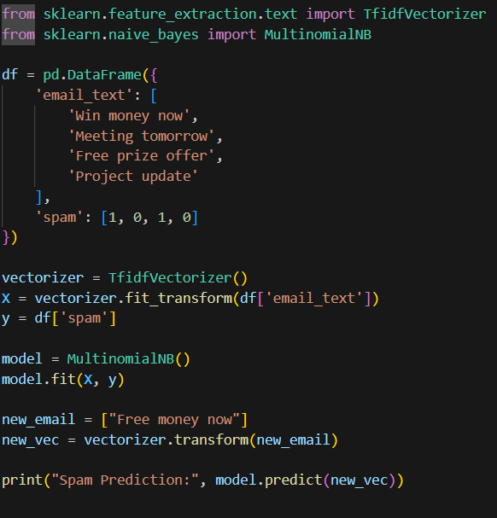
OUTPUT


Question 4
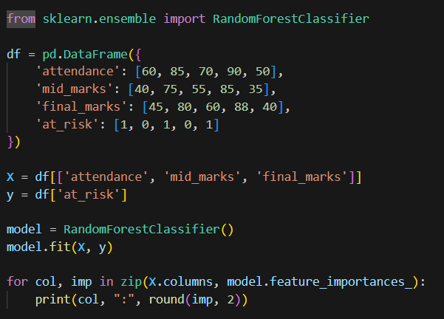
OUTPUT
